

## Smoke Detector and Alarm Generator

GE101 Project

Group – 10 [ME]

## Name of the Group Members:

* Bhuvan Nawaria - 2021meb1276
* Deepak Soni - 2021meb1279
* Gursimer Singh - 2021meb1285
* Harshvardhan Singh - 2021meb1287
* Kayitha Saran Yadav - 2021meb1290
* Korupolu Deekshitha - 2021meb1292

Index:

|  |  |
| --- | --- |
| S.No | Title |
| 1. | Introduction |
| 2. | Purpose of project |
| 3. | Materials Required |
| 4. | Circuit connection and Code |
| 5. | Working Principle |
| 6. | Applications |
| 7. | Conclusion |

## Introduction:

A smoke detector tinkering project involves modifying or building a smoke detector to customize its features or to create a unique smoke detection system. Smoke detectors are devices that detect smoke and alert occupants of a building or home to the presence of a potential fire. The basic function of a smoke detector is to sense smoke and trigger an alarm to warn people of a fire.

## Purpose of Project:

This project aims to create and implement a smoke detector and alarm generator system that can quickly and accurately identify smoke and generate an alarm to notify building occupants of its presence. The system should be dependable, affordable, simple to keep, and able to run for long periods of time without requiring frequent battery changes. The system will be tested in various real-world situations as part of the project to ensure it offers the best fire protection possible.

## Materials Required:

9-volt battery-Smoke detectors typically require a battery or connection to an electrical outlet to operate.

• battery connector-for connecting the battery

• small speaker or buzzer This is the component that detects the presence of smoke in the air.

photoresistor or light-dependent resistor (LDR)- In a smoke detector, an LDR is used as part of the sensing mechanism to detect the presence of smoke or other airborne particles.

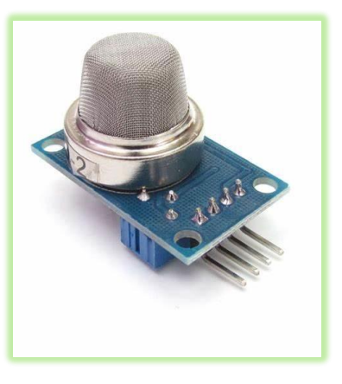

The LDR is paired with a light source, such as an LED, and a small chamber in an optical smoke detector. The light source emits a beam of light that is directed toward the LDR, which is positioned opposite the light source. When smoke particles enter the chamber, they scatter the light, causing some of it to reach the LDR. The presence of smoke causes the LDR's resistance to change, which is detected by the circuitry of the smoke detector, triggering the alarm,

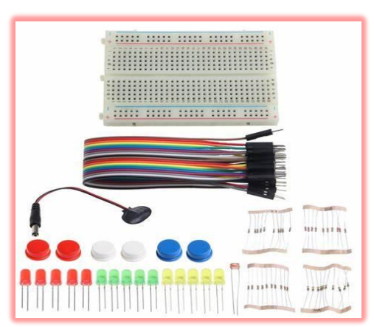

• 10K ohm resistor for controlling the voltage received by the bulb

• small breadboard or circuit board for putting up all the connections

• Led lights-We are using the LED lights to detect the presence of smoke or other potential hazards.

• ARDUINO/ESP32-to feed the code into the circuit

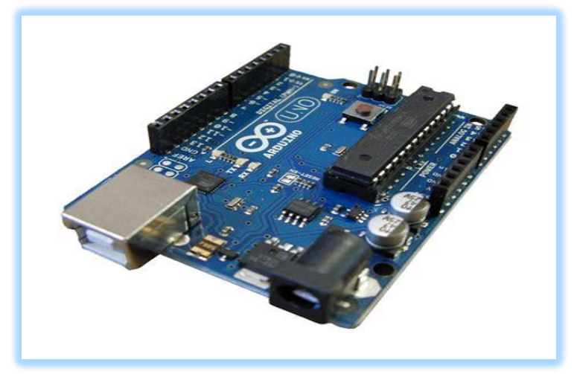

## Circuit Connection and Code:

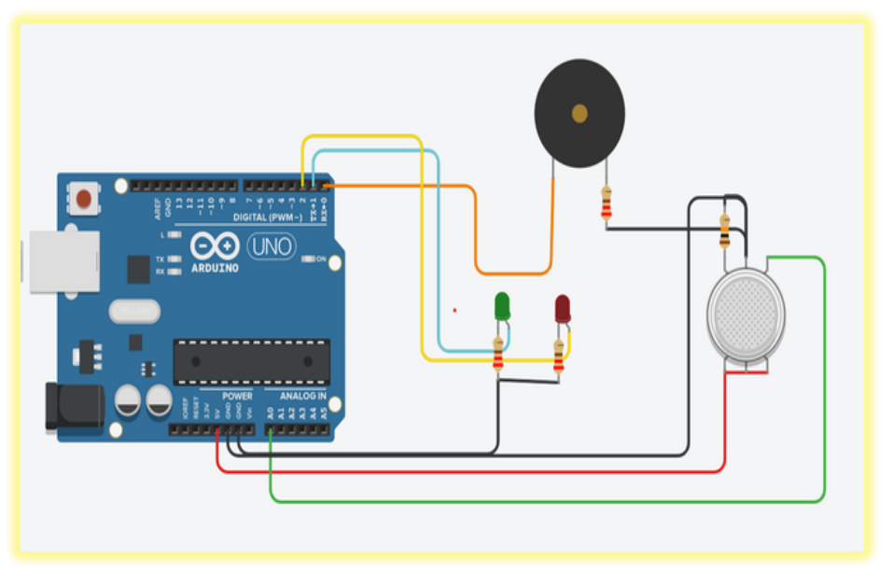

[Circuit made in TinkerCad]

[Original Circuit]

Code:

int ledPin1 = 2; // The first LED is connected to digital pin 2

int ledPin2 = 3; // The second LED is connected to digital pin 3

int buzzerPin = 4; // The buzzer is connected to digital pin 4

int sensorPin = A0; // The MQ2 sensor is connected to analog pin A0

int delayTime = 1000; // The initial delay time is set to 1000 milliseconds

int buzzerFrequency = 1000; // The initial frequency of the buzzer is set to 1000 Hz

void setup() {

pinMode(ledPin1, OUTPUT); // Set the first LED pin as output

pinMode(ledPin2, OUTPUT); // Set the second LED pin as output

pinMode(buzzerPin, OUTPUT); // Set the buzzer pin as output

pinMode(sensorPin, INPUT); // Set the MQ2 sensor pin as input

}

void loop() {

int sensorValue = analogRead(sensorPin); // Read the sensor value

if (sensorValue > 500) { // If the sensor value is above the threshold

digitalWrite(ledPin1, HIGH); // Turn on the first LED

tone(buzzerPin, buzzerFrequency); // Turn on the buzzer with the current frequency

delay(delayTime); // Wait for delayTime milliseconds

digitalWrite(ledPin1, LOW); // Turn off the first LED

noTone(buzzerPin); // Turn off the buzzer

digitalWrite(ledPin2, HIGH); // Turn on the second LED

tone(buzzerPin, buzzerFrequency); // Turn on the buzzer with the current frequency

delay(delayTime); // Wait for delayTime milliseconds

digitalWrite(ledPin2, LOW); // Turn off the second LED

noTone(buzzerPin); // Turn off the buzzer

delayTime = delayTime + 100; // Increase the delay time by 100 milliseconds

buzzerFrequency = buzzerFrequency + 50; // Increase the frequency of the buzzer by 50 Hz

if (delayTime > 1000) { // If the delay time is more than 1000 milliseconds

delayTime = 100; // Reset the delay time to 100 milliseconds

buzzerFrequency = 1000; // Reset the frequency of the buzzer to 1000 Hz

}

} else { // If the sensor value is below the threshold

digitalWrite(ledPin1, LOW); // Turn off the first LED

digitalWrite(ledPin2, LOW); // Turn off the second LED

noTone(buzzerPin); // Turn off the buzzer

  }

}

## Working Principle:

The working principle of a smoke detector made using Arduino and MQ2 sensor is based on the ability of the MQ2 sensor to detect smoke particles in the air. The MQ2 sensor detects smoke particles by measuring the resistance changes caused by the presence of smoke. When smoke particles enter the MQ2 sensor, they interact with the sensing material inside the sensor, causing the resistance to decrease. This change in resistance is then measured by the Arduino board, which can trigger an alarm or other actions based on the measured values.

The Arduino board is programmed to read the output signal from the MQ2 sensor and then process this signal to determine if smoke is present. If smoke is detected, the Arduino board activates an alarm, which can be in the form of a buzzer or LED lights, to alert the user. The alarm will continue until the smoke has cleared from the sensor, and the resistance has returned to its original state.

In summary, the MQ2 sensor detects smoke particles, and the Arduino board processes the signal to activate an alarm if smoke is detected. This smoke detector is an effective way to detect smoke and prevent potential fire hazards.

## Applications:

Smoke detectors are essential safety devices that are designed to detect the presence of smoke in the air and alert people to the possibility of a fire. Some of the applications of smoke detectors are below:

1)Home Safety: Smoke detectors are commonly installed in homes to provide early warning of fire. They can help to alert people to the presence of smoke and allow them to take action to prevent injury or property damage.

2)Commercial Safety: Smoke detectors are commonly used in commercial buildings to help protect occupants and property. They are required by law in many jurisdictions.

3)Industrial safety: Smoke detectors are commonly used in industrial settings to help protect workers and equipment. They can be used to detect smoke from combustible materials, chemical reactions, and other hazards.

4) Airplane safety: Smoke detectors are used on airplanes to help detect smoke in the cabin or cargo hold. This can help to prevent fires and ensure the safety of passengers and crew.

5)Marine Safety: Smoke detectors are commonly used on boats and ships to help detect fires and smoke. They can be used to alert crew members and passengers to the presence of smoke and allow them to take appropriate action.

Overall, smoke detectors are essential safety devices that can help to prevent injury, and property damage, and even save lives....

## Conclusion:

Through the use of Arduino and gas sensors, we were able to create a reliable and accurate smoke detector that is responsive to different types of smoke and gas emissions. The system was able to detect the presence of smoke or gas in the environment and trigger an alarm to alert the user.

Overall, our smoke detector project using Arduino and a gas kit has great potential for use in homes, offices, and other public spaces. Its low cost and easy-to-use features make it an excellent solution for enhancing safety and preventing fires. We hope that this project will inspire further research and development in the field of smoke detector technology.